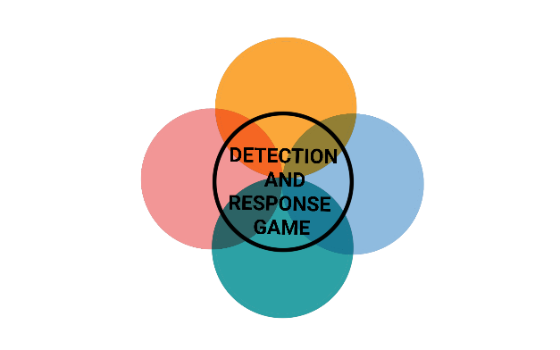

**INITIAL ACCESS**



**INITIAL ACCESS**



**INITIAL ACCESS**



**INITIAL ACCESS**



**INITIAL ACCESS**



**INITIAL ACCESS**



**INITIAL ACCESS**



**INITIAL ACCESS**



**INITIAL ACCESS**



**INITIAL ACCESS**



**INITIAL ACCESS**



**INITIAL ACCESS**

**VALID ACCOUNT VPN**

Phishing campaigns against individual victims.

DETECTION

* Check the Sender & Domain
* Security awareness training

MITIGATION

* Anti-impersonation technology
* Email scanning technology

IMPACT

* Loss of Intellectual Property
* Damage to Reputation

**ATTACHMENT PHISHING**

Emails with a malicious attachment.

DETECTION

* Check the Sender & Domain
* Security awareness training

MITIGATION

* Anti-impersonation technology
* Email scanning technology

IMPACT

* Loss of Intellectual Property
* Damage to Reputation

**URL PHISHING**

Emails with a malicious link.

DETECTION

* Check the Sender & Domain
* Security awareness training

MITIGATION

* Anti-impersonation technology
* Email scanning technology

IMPACT

* Loss of Intellectual Property
* Damage to Reputation

**SPEARPHISHING**

Phishing campaigns against individual victims.

DETECTION

* Check the Sender & Domain
* Security awareness training

MITIGATION

* Anti-impersonation technology
* Email scanning technology

IMPACT

* Loss of Intellectual Property
* Damage to Reputation



**INITIAL ACCESS**



**INITIAL ACCESS**



**INITIAL ACCESS**



**INITIAL ACCESS**

**WATERING HOLE ATTACK**

Phishing campaigns against individual victims.

DETECTION

* Check the Sender & Domain
* Security awareness training

MITIGATION

* Anti-impersonation technology
* Email scanning technology

IMPACT

* Loss of Intellectual Property
* Damage to Reputation

**TRUSTED RELATIONSHIP**

Phishing campaigns against individual victims.

DETECTION

* Check the Sender & Domain
* Security awareness training

MITIGATION

* Anti-impersonation technology
* Email scanning technology

IMPACT

* Loss of Intellectual Property
* Damage to Reputation

**SQL INJECTION**

Phishing campaigns against individual victims.

DETECTION

* Check the Sender & Domain
* Security awareness training

MITIGATION

* Anti-impersonation technology
* Email scanning technology

IMPACT

* Loss of Intellectual Property
* Damage to Reputation

**USB RUBBER DUCKY**

Phishing campaigns against individual victims.

DETECTION

* Check the Sender & Domain
* Security awareness training

MITIGATION

* Anti-impersonation technology
* Email scanning technology

IMPACT

* Loss of Intellectual Property
* Damage to Reputation